**NAME : SHABRINA QOTTRUNNADA**

**NIM : 2341760160**

**PRODI/CLASS : SIB/1G**

**MATKUL : PRAKTIKUM ALHORITMA DAN STRUKTUR DATA (SEARCHING)**

**Github :** [**https://github.com/shabrinaq/smstr2_Jobsheet6/tree/main**](https://github.com/shabrinaq/smstr2_Jobsheet6/tree/main)

**1.2.1 Steps**

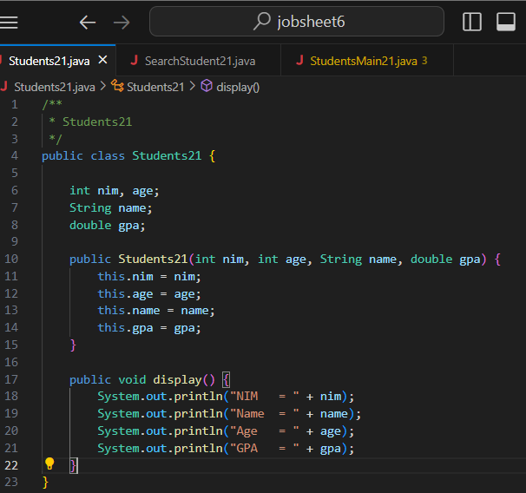

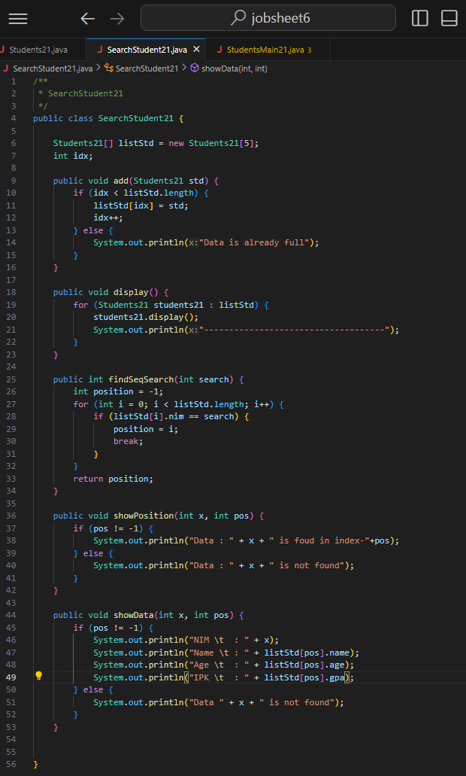

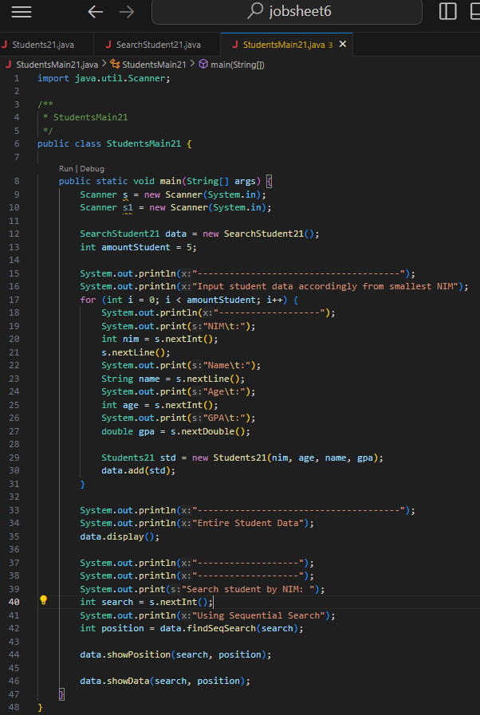

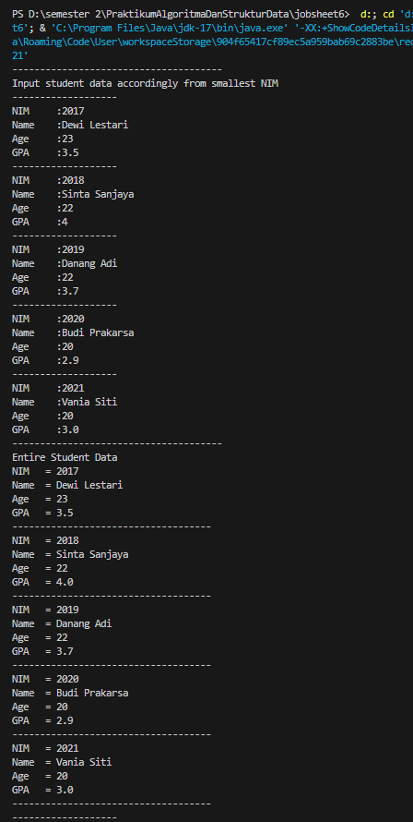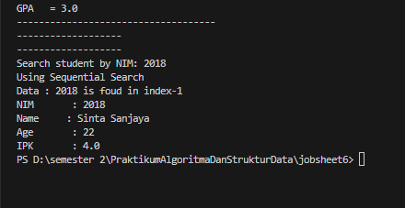**1.2.2 Result**

**1.2.3. Question**

1. What is the difference of method displayData and displayPosition in StudentSearch class?

* displayData 🡺 to display all student data in listStd that is called by the display() method of object Student21
* displayPosition 🡺 to display detailed student data based on their searched NIM, which includes their NIM, Name, Age, and GPA

1. What is the function of break in this following program code?

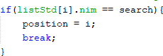

* In the program code, break functions as a program code to stop the 'for' looping that is happening, this happens when the condition has been met so it must be stopped with the 'break' program code

1. If inserted NIM data is not sorted from smallest to biggest value, will the program encounter an error? Is the result still correct? Why is that?

* if the NIM data is entered out of order from the smallest to the largest value, the program will not experience errors, but the output produced when it is run will not be what we want

**1.3.1 Steps**

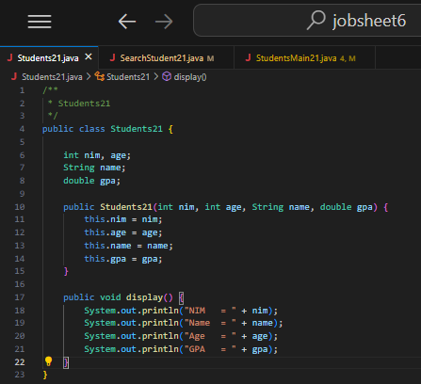

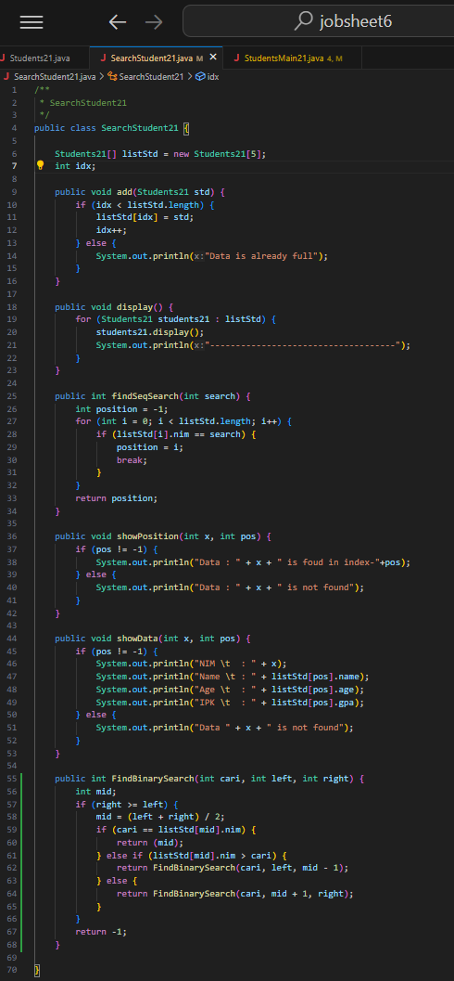

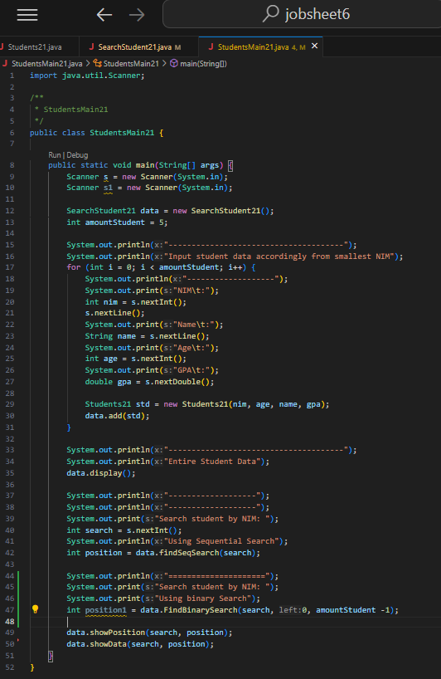

* + 1. **Result**

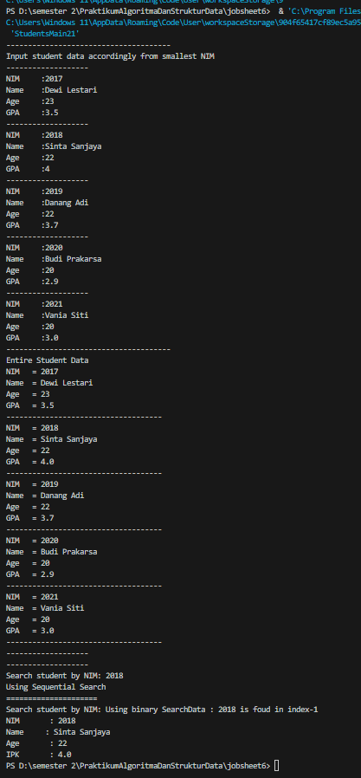

## 1.3.3 Question

* + - 1. Show the program code in which runs the divide process



* + - 1. ****Show the program code in which runs the conquer process



* + - 1. If inserted NIM data is not sorted, will the program crash? Why?

If inserted NIM data is sorted from largest to smallest value (e.g 20215, 20214 20212, 20211,20210) and element being searched is 20210. How is the result of binary search? does it return the correct one? if not, then change the code so that the binary search executed properly

* Jika data NIM diinputkan dengan cara tidak urut, nantinya program tidak mengalami crash, tapii data biner membutuhkan suatu data yang urut untuk mengahsilkan output yang sesuai dengan keinginan kita
* Jika data NIM yang diinputkan dari data terkecil (nisal 20215, 20214, 20212, 20211, 20210) dan elemen yang dicari adalah 20210, maka output yang dihasilkan akan tidak sesuai dengan yang kita mau, karena biner mengiranya kita mengurutkannya dari yang terkecil ke terbesar ataupun sebaliknya, maka dari itu output yang dihasilkan akan tidak sesuai
  + - 1. Modify program above so that the students amount inserted is matched with user input